Definitions of Behavioural Design Patterns
- As mentioned previously, Behavioural Design Patterns are design patterns that focus on how objects interact and communicate with each other, emphasising the distribution of responsibilities and algorithms.
- Behavioural patterns define ways to manage communication and collaboration between objects, ensuring that interactions are efficient, flexible, and loosely coupled.
- These patterns are concerned with assigning responsibilities to objects and defining how they work together to achieve a task or solve a problem.
- Behavioural patterns encapsulate algorithms and behaviours in objects, making them interchangeable, reusable, and easier to manage.
- Behavioural patterns enable event-driven communication between objects, allowing them to notify and update each other when changes occur.
- These patterns provide solutions for managing complex workflows and processes, ensuring that tasks are handled efficiently and flexibly.

Summary
Behavioural Design Patterns are focused on object interaction, communication, and responsibility management. They provide structured solutions for handling algorithms, workflows, events, and state changes, making systems more flexible, maintainable, and scalable. Whether it’s managing complex workflows or enabling dynamic behaviour, these patterns play a crucial role in designing robust and efficient software systems.

Why Behavioural Design Patterns Matter
Behavioural Design Patterns are essential in software development for managing how objects interact and communicate. Here’s a list of reasons why they matter:

Promote Loose Coupling
Behavioural patterns reduce dependencies between objects, making systems more modular and easier to maintain.
Example: The Observer pattern decouples event sources from event handlers.

Improve Flexibility
These patterns make systems more adaptable to change by encapsulating behaviours and allowing them to be swapped or extended.
Example: The Strategy pattern allows algorithms to be interchangeable at runtime.

Enhance Reusability
Behavioural patterns encapsulate reusable behaviours, reducing code duplication and improving efficiency.
Example: The Template Method pattern defines a reusable algorithm skeleton.

Simplify Complex Workflows
They provide structured solutions for managing complex interactions and workflows.
Example: The Chain of Responsibility pattern simplifies request processing by passing it through a chain of handlers.

Enable Dynamic Behaviour
Behavioural patterns allow objects to change their behaviour based on internal state or external conditions.
Example: The State pattern enables an object to alter its behaviour when its state changes.

Facilitate Event-Driven Communication
These patterns enable objects to notify and update each other when changes occur, supporting event-driven systems.
Example: The Observer pattern is widely used in GUI frameworks and real-time systems.

Encapsulate Algorithms
Behavioural patterns encapsulate algorithms and behaviours, making them easier to manage and extend.
Example: The Command pattern encapsulates requests as objects, allowing them to be parameterised and queued.

Improve Maintainability
By organising object interactions in a structured way, behavioural patterns make systems easier to understand and maintain.
Example: The Template Method pattern centralises algorithm logic, reducing duplication and errors.

Support Scalability
Behavioural patterns make it easier to scale systems by providing flexible and modular interaction mechanisms.
Example: The Chain of Responsibility pattern allows new handlers to be added without modifying existing code.

Encourage Best Practices
These patterns promote best practices like encapsulation, separation of concerns, and single responsibility.
Example: The Strategy pattern separates algorithm implementation from the context that uses it.

Enhance Collaboration
Behavioural patterns provide a common vocabulary for developers, making it easier to discuss and implement solutions.
Example: Using the Observer pattern ensures that all team members understand how event-driven communication works.

Optimise Resource Usage
Some behavioural patterns optimise resource usage by managing object interactions efficiently.
Example: The Flyweight pattern (a structural pattern with behavioural aspects) reduces memory usage by sharing data between objects.

Enable Undo/Redo Functionality
Behavioural patterns like Command make it easier to implement undo/redo functionality in applications.
Example: The Command pattern encapsulates actions as objects, allowing them to be stored and replayed.

Support State Management
Behavioural patterns help manage object states and transitions, making systems more robust and predictable.
Example: The State pattern simplifies state management by encapsulating state-specific behaviour.

Facilitate Testing
By decoupling objects and encapsulating behaviours, behavioural patterns make systems easier to test.
Example: The Strategy pattern allows algorithms to be tested independently of the context that uses them.

Summary
Behavioural Design Patterns matter because they improve flexibility, maintainability, and scalability in software systems. They promote loose coupling, encapsulate behaviours, and provide structured solutions for managing complex interactions. By using these patterns, developers can build systems that are easier to understand, extend, and maintain, while also supporting dynamic behaviour and event-driven communication.

Applications of Behavioural Design Patterns
Behavioural Design Patterns are widely used in software development to manage object interaction, communication, and workflows. Here are some key applications of these patterns:
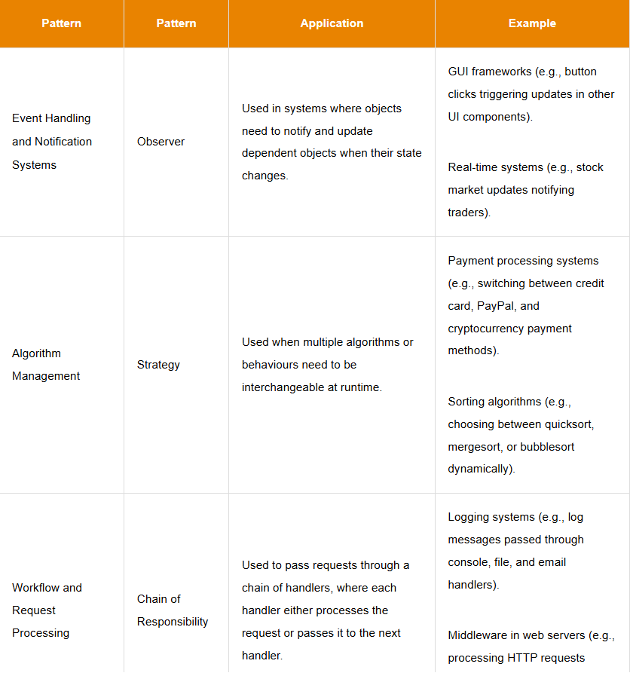
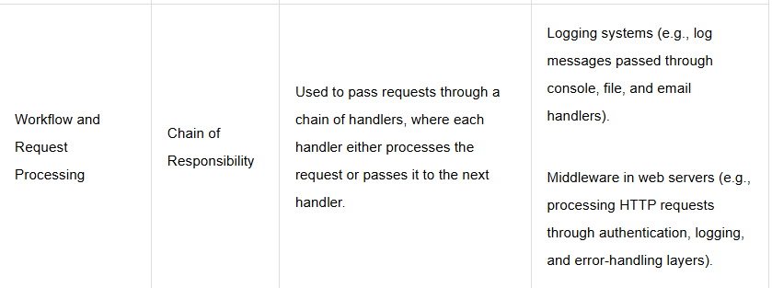
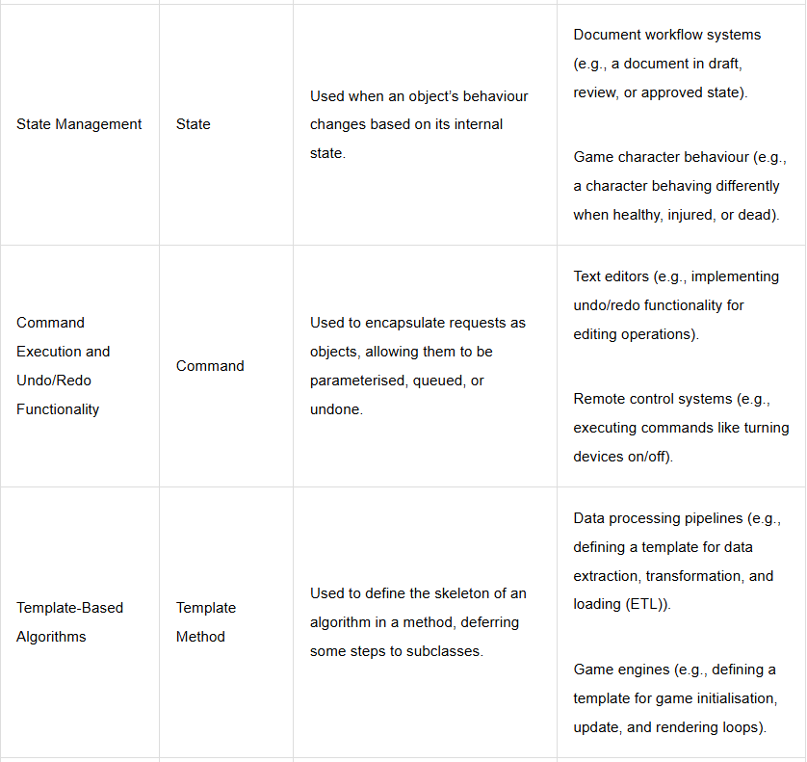
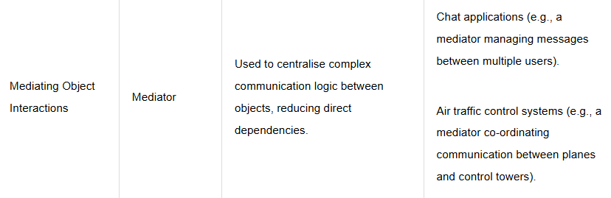

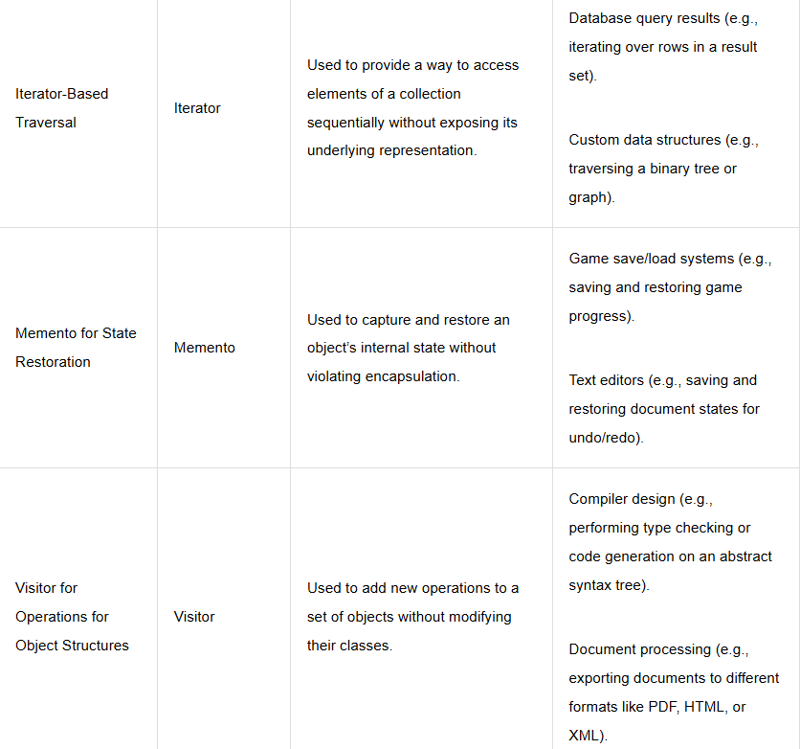
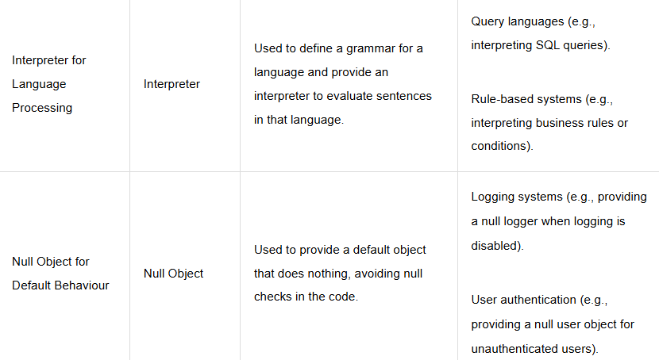

Drawbacks of Behavioural Design Patterns
While Behavioural Design Patterns offer numerous benefits, they also come with certain drawbacks.
Here’s a list of potential drawbacks associated with these patterns:
1. Increased Complexity
• Behavioural patterns can introduce additional layers of abstraction, making the codebase
more complex and harder to understand.
• Example: The Observer pattern can lead to complex event-handling logic if not managed
properly.
2. Overhead
• Some patterns add unnecessary overhead if applied to simple problems where they are
not needed.
• Example: Using the Command pattern for simple operations can introduce unnecessary
complexity.
3. Over-Engineering
• Applying behavioural patterns inappropriately can lead to over-engineering, where the
solution is more complex than the problem requires.
• Example: Using the State pattern for objects with few state transitions can be overkill.
4. Tight Coupling in Some Cases
• Certain patterns can lead to tight coupling between classes if not implemented carefully.
• Example: The Mediator pattern can create tight coupling between the mediator and the
objects it manages.
5. Performance Issues
• Some patterns may introduce performance overhead due to additional layers of
abstraction or object interactions.
• Example: The Chain of Responsibility pattern can introduce latency if the chain is too
long.
6. Learning Curve
• Understanding and correctly applying behavioural patterns requires a solid grasp of OOP
principles, which can be challenging for beginners.
• Example: The Visitor pattern can be difficult to implement correctly without a deep
understanding of object relationships.
7. Maintenance Challenges
• While patterns improve maintainability in some cases, they can also make maintenance
harder if not documented properly or if the pattern is misapplied.
• Example: A poorly documented Observer pattern implementation can make it difficult for
new developers to understand the event-handling logic.
8. Limited Flexibility in Some Patterns
• Some patterns, like the Template Method, can limit flexibility by enforcing a specific
algorithm structure.
• Example: The Template Method pattern can make it difficult to modify the algorithm’s
steps without changing the template.
9. Dependency Management
• behavioural patterns can sometimes make it harder to manage dependencies, especially
if the patterns are not used correctly.
• Example: The Mediator (واسطه) pattern can lead to dependency issues if the mediator becomes a
bottleneck.
10. Potential for Misuse
• Patterns can be misused or overused, leading to inefficient or overly complex designs.
• Example: Using the Chain of Responsibility pattern for simple request handling can lead
to unnecessary complexity.
11. Difficulty in Debugging
• Patterns that involve multiple layers of abstraction can make debugging more challenging.
• Example: Debugging issues in a system that heavily uses the Observer pattern can be
difficult due to the indirection.
12. Scalability Issues
• Some patterns may not scale well for very large systems or systems with highly dynamic
interaction requirements.
• Example: The Observer pattern can become a bottleneck in highly concurrent systems
with many observers.
13. State Management Complexity
• Patterns like State can introduce complexity in managing state transitions and ensuring
consistency.
• Example: The State pattern can lead to complex state transition logic if not designed
carefully.
14. Testing Challenges
• Some patterns can make unit testing more challenging due to increased dependencies or
indirection.
• Example: Testing a system that uses the Command pattern may require mocking multiple
command objects.
15. Increased Memory Usage
• Some patterns, like Observer, can increase memory usage due to the need to maintain
lists of observers or handlers.
• Example: The Observer pattern can lead to high memory usage if there are many
observers for a single subject.

Key Behavioural Design Patterns

Behavioural Design Patterns focus on how objects interact and communicate with each other, emphasising the distribution of responsibilities and algorithms.

1 - Strategy Pattern:
Purpose: Defines a family of algorithms, encapsulates each one, and makes them interchangeable.
Use Case: When you need to switch between different algorithms or behaviours at runtime.

# 1. Importing necessary modules
- from abc import ABC, abstractmethod: Imports the ABC (Abstract Base Class) and abstractmethod from the abc module, which are used to create abstract classes and methods.
from abc import ABC, abstractmethod
# 2. Defining the Strategy interface
- class PaymentStrategy(ABC):: Defines an abstract base class PaymentStrategy that serves as the Strategy interface. All concrete strategy classes will inherit from this interface.
- @abstractmethod: This decorator is used to define pay() as an abstract method, which must be implemented by concrete strategy classes.
# Strategy Interface
class PaymentStrategy(ABC):
@abstractmethod
def pay(self, amount):
pass

3. Defining concrete strategies
- class CreditCardStrategy(PaymentStrategy): and class PayPalStrategy(PaymentStrategy):: Define concrete strategy classes CreditCardStrategy and PayPalStrategy, both inheriting from the PaymentStrategy interface.
- def pay(self, amount):: Each concrete strategy implements the pay() method from the PaymentStrategy interface. They provide different payment strategies (Credit Card and PayPal) and return a message indicating the payment method used.

# Concrete Strategies
class CreditCardStrategy(PaymentStrategy):
def pay(self, amount):
return f"Paid ${amount} using Credit Card"

class PayPalStrategy(PaymentStrategy):
def pay(self, amount):
return f"Paid ${amount} using PayPal"

4. Creating the Context
- class PaymentProcessor: Defines a PaymentProcessor class that encapsulates the strategy used for payment processing.
- def __init__(self, strategy: PaymentStrategy): Constructor method that initializes the PaymentProcessor with a PaymentStrategy object as a parameter. The strategy is stored in the self.strategy attribute.
- def set_strategy(self, strategy: PaymentStrategy): Allows the strategy to be changed at runtime by updating the self.strategy attribute with a new PaymentStrategy object.
- def execute_payment(self, amount): Executes the payment by calling the pay() method of the current strategy object with the given amount.
# Context
class PaymentProcessor:
def __init__(self, strategy: PaymentStrategy):
self.strategy = strategy

def set_strategy(self, strategy: PaymentStrategy):
self.strategy = strategy

def execute_payment(self, amount):
return self.strategy.pay(amount)

5. Client Code
- processor = PaymentProcessor(CreditCardStrategy()): Creates a PaymentProcessor object, passing a CreditCardStrategy object as the initial payment strategy.
- print(processor.execute_payment(100)): Executes a payment of $100 using the CreditCardStrategy.
- processor.set_strategy(PayPalStrategy()): Updates the payment strategy to PayPalStrategy.
- print(processor.execute_payment(100)): Executes another payment of $100, this time using the new PayPalStrategy.

# Client Code
processor = PaymentProcessor(CreditCardStrategy())
print(processor.execute_payment(100)) # Output: Paid $100 using Credit Card

processor.set_strategy(PayPalStrategy())
print(processor.execute_payment(50)) # Output: Paid $50 using PayPal
# The Strategy pattern encapsulates interchangeable behaviour (payment strategies) and allows them to be selected at runtime, promoting flexibility and decoupling the algorithm from the client that uses it.

2 - Observer Pattern:
Purpose: Allows objects to notify and update dependent objects when their state changes.
Use Case: Event-driven systems like GUI frameworks or real-time notifications.
- # Subject class represents the Subject in the Observer pattern, which is observed by one or more Observer objects.

class Subject:

# Initializes the Subject object and creates an empty list _observers to #store references to attached observers.
def __init__(self):
self._observers = []

# This method allows observers to register themselves with the Subject by #appending them to the _observers list.

def attach(self, observer):
self._observers.append(observer)

# The notify() method loops through all registered observers and calls their update() method, notifying them of any state changes in the Subject.

def notify(self):
for observer in self._observers:
observer.update(self)

# Observer class - This is an abstract class that represents the base class for all Observer objects. The update() method is defined as a placeholder in the abstract Observer class. Actual behaviour will be implemented by concrete subclasses.

class Observer:
def update(self, subject):
pass

# ConcreteObserver class - In this example, the update() method simply prints a message indicating that the observer has been notified of a state change in the Subject.

class ConcreteObserver(Observer):
def update(self, subject):
print("Observer notified of state change")

# Client Code

# Creates a Subject object.
subject = Subject()
# Creates a ConcreteObserver object.
observer = ConcreteObserver()
# Attaches the observer to the subject so that it will be notified when the #subject changes its state.
subject.attach(observer)

# Notifies all registered observers of a state change in the Subject. This #triggers the update() method in the registered ConcreteObserver, which #prints the message "Observer notified of state change".
#In this example, subject is an instance of the Subject class, and when subject.notify() is called, the notify method is executed on this subject instance. Inside the notify method, self will refer to this specific subject instance.

subject.notify() # Output: Observer notified of state change
# The Observer design pattern allows a subject to maintain a list of observers and notify them of any changes to its state, promoting loose coupling between the subject and observers. This code example demonstrates a basic implementation of the Observer pattern in Python.
Subject: A subject is an object that is being observed by one or more observers. It keeps track of its observers and notifies them of any state changes, usually by calling an update method on each observer. The subject doesn't know the details of the observers; it only knows that it needs to notify them.
Observer: An observer is an object that is interested in the changes of the subject's state. Observers can register with the subject to receive notifications when the subject's state changes. When notified by the subject, observers can perform specific actions based on the state change. Observers are loosely coupled to the subject, allowing for easy addition, removal, or modification of observers without affecting the subject.
Real-world example:
Consider a social media platform where users can follow other users. In this case, a user being followed can be considered a "subject," and their followers are "observers."
When a user makes a post, their followers (observers) are notified about the new content. The followers can react to the post, comment, or share it. The user (subject) doesn't need to know the details of their followers' reactions or actions. This is an example of the Observer pattern in a real-world scenario.

3 - Chain of Responsibility Pattern:
Purpose: Passes a request along a chain of handlers, where each handler either processes the request or passes it to the next handler.
Use Case: Logging systems, middleware, or request processing pipelines.
class Handler(ABC):
def __init__(self, successor=None):
self._successor = successor

def handle(self, request):
if self._successor:
return self._successor.handle(request)
return None

class ConcreteHandler1(Handler):
def handle(self, request):
if request == "Request1":
return f"ConcreteHandler1 handled {request}"
else:
return super().handle(request)

class ConcreteHandler2(Handler):
def handle(self, request):
if request == "Request2":
return f"ConcreteHandler2 handled {request}"
else:
return super().handle(request)

# Client Code
handler_chain = ConcreteHandler1(ConcreteHandler2())
print(handler_chain.handle("Request1")) # Output: ConcreteHandler1 handled Request1
print(handler_chain.handle("Request2")) # Output: ConcreteHandler2 handled Request2

4- Template Method Pattern:
Purpose: Defines the skeleton of an algorithm in a method, deferring some steps to subclasses.
Use Case: When you want to enforce a common algorithm structure but allow subclasses to customise specific steps.
from abc import ABC, abstractmethod

class Game(ABC):
def play(self):
self.initialize()
self.start_play()
self.end_play()

@abstractmethod
def initialize(self):
pass

@abstractmethod
def start_play(self):
pass

@abstractmethod
def end_play(self):
pass

class Cricket(Game):
def initialize(self):
print("Cricket Game Initialized")

def start_play(self):
print("Cricket Game Started")

def end_play(self):
print("Cricket Game Ended")

# Client Code
game = Cricket()
game.play()
# Output:
# Cricket Game Initialized
# Cricket Game Started
# Cricket Game Ended

5 - Command Pattern:
Purpose: Encapsulates a request as an object, allowing parameterisation and queuing of requests.
Use Case: Implementing undo/redo functionality or queuing requests.
class Command(ABC):
@abstractmethod
def execute(self):
pass

class LightOnCommand(Command):
def __init__(self, light):
self._light = light

def execute(self):
self._light.on()

class Light:
def on(self):
print("Light is ON")

# Client Code
light = Light()
command = LightOnCommand(light)
command.execute() # Output: Light is ON

6 - State Pattern:
Purpose: Allows an object to alter its behaviour when its internal state changes.
Use Case: Workflow systems, game character behaviour, or state machines.
class State(ABC):
@abstractmethod
def handle(self):
pass

class ConcreteStateA(State):
def handle(self):
print("Handling State A")

class ConcreteStateB(State):
def handle(self):
print("Handling State B")

class Context:
def __init__(self, state: State):
self._state = state

def set_state(self, state: State):
self._state = state

def request(self):
self._state.handle()

# Client Code
context = Context(ConcreteStateA())
context.request() # Output: Handling State A

context.set_state(ConcreteStateB())
context.request() # Output: Handling State B

These Behavioural Design Patterns provide structured solutions for managing object interactions, communication, and workflows. By understanding and applying these patterns, you can create systems that are flexible, maintainable, and scalable. Each pattern comes with a programming exercise to help you practice and reinforce your understanding.

Reference

The materials in this document retrieved from University of Essex Online Learning platform available at: https://www.my-course.co.uk/mod/scorm/player.php?a=21872&currentorg=articulate_rise&scoid=43823&sesskey=9TB6KMDoN4&display=popup&mode=normal Accessed 19 November 2025

